Note: The exam will be all multiple choice problems. You need bring scantron to the exam. The sample exam is only for practice purpose. The total credits for the first exams are 100 pints.
Determine whether that data are quantitative (A) or qualitative (L).
1. The telephone number in a telephone directory A L
2. The daily high temperatures for the month of July A L
3. The lengths of songs on an MP3 player A L

Identifying sampling techniques
4. For quality assurance, every twentieth engine part is selected from an assembly line and tested for durability.
Systematic

Identify populations and samples
5. A survey of 1000 adults in the United States found that 12% prefer to take their vacation during the winter months.
6. A study of 33043 infants in Italy was conducted to find a link between a heart rhythm abnormality and sudden infant death syndrome.

Distinguishing between a parameter (P) and a statistic (S)
7. In a survey of a sample of high school students, 43% said their mother has taught them the most about managing money. P S
8. As of January 2007, 44% of the governors of the 50 states in the United States are Republicans.
P S

True or False
9. A statistic is a measure that measures a population characteristic. T F
10. A sample is a subset of a population. T F
11. It is impossible for the Census Bureau to obtain all the census data about the population of the United States. T F
12. Inferential statistics involves using a population to draw a conclusion about a corresponding sample. T F
13. A population is the collection of some units of interest. T F

Suppose that a group of people is randomly selected at a shopping mall. Each person in the sample is shown a typical cigarette advertisement and is asked to estimate the age of the model in the ad.
26 31 30 28 29 30 28 28 26 31 23 24 25
24 27 27 26 31 30 17 27 29 22 27 30 31
14. How many classes should be used for the Histogram? 5

15. Please develop a frequency distribution, and relative frequency distribution.
17≤x<20 | 1
20≤x<23 | 1
23≤x<26 | 4
26≤x<29 | 10
29≤x<32 | 10

16. Draw a histogram and describe the shape of distribution.
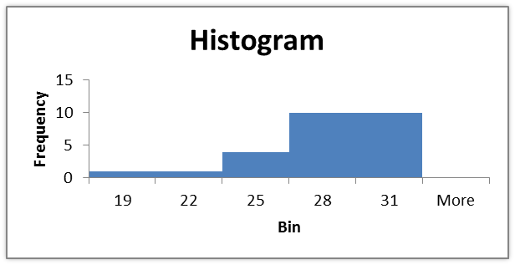

17. Make a Stem-and-Leaf plot.
1 | 7
2 | 2 | 3 | 4 | 4 | 5 | 6 | 6 | 6 | 7 | 7 | 7 | 7 | 8 | 8 | 8 | 9
3 | 0 | 0 | 0 | 0 | 1 | 1 | 2 | 2

18. Find out the Mode, Median, 65th percentile, Q1, Q3 and IQR.
Mode 27, 30
Median 27
65th percentile 29
Q1 25.5, Q3 30, IQR 4.5
19. For the data set below please calculate the population mean and variance.
4, 3, 6, 10, 6
5.8; 5.76
20. For the data set below please calculate the sample mean and variance.
4, 3, 6, 10, 6
5.8; 7.2

21. Let A, B, C, and D be sample space outcomes forming a sample space. Which one of the following is a legitimate way to assign probabilities to the sample space?
P(A)=0.5; P(B)=0.4; P(C)=0.1; P(D)=0; P(A)=0.5; P(B)=0.4; P(C)=0.1; P(D)=0.1; the sum is 1.1
P(A)=0.5; P(B)=1.2; P(C)=0.1; P(D)=0; P(A)=0.5; P(B)=0.3; P(C)=0; P(D)=0.2;
22. Let A, B, C, D, and E be sample space outcomes forming a sample space. Suppose P(A)=0.5, P(B)=0.15, P(C)=0.25, and P(D)=0. What is P(E)? 0.10

23. The probability that a student fails STAT 3309 is 0.10. What is the probability that a student passes STAT 3309? 0.9
24. An insurance company sells an insurance policy to a 20 years old female driver for $1000 per year. It is known that the probability for 20 year old female driver to have accident(s) in one year is 0.000012 and the total compensation is on average equal to $200000. Let x denote the company’s profit for the policy on this 20 years old female driver.

(a) Set up the probability distribution of the random variable x.
-199000 | 0.000012
1000 | 0.999988

(b) Calculate the mean of x. 997.6
(c) Calculate the variance of x. 479994.24
25. Thirty percent of all customers who enter a store will make a purchase. Suppose that 6 customers enter the store and that these customers make independent purchased decisions.
(a) Let X= the number of the six customers who will make a purchase. Write the binomial formula for this situation.
Binomial with p=0.3, n=6
(b) What is the mean and variance of X? 1.8; 1.26
(c) Calculate the probability that at least one customer makes a purchase. 1-0.1176
26. For an unfair coin the probability to toss a Head is 0.4. Toss the coin 10 times. Let X be the total number of Heads. Identify the distribution of X and calculate P(X=2).
Binomial with n=10, p=0.4; 0.1209
27. The table contains the probability for the number of rainy days in Seattle during the spring.
X=0 | 0
X=1 | 0.2
X=2 | 0.2
X=3 | 0.3
X=4 | 0.1
X=5 | 0.1
X=6 | 0.05
X=7 | 0.05
What is the probability that at most 7 days are rainy days? 1
What is the probability that at least 3 days are rainy days? 0.6
What is the probability that no more than 2 days are rainy days? 0.4

() (4, 6)
68.26% (5.46-2.475, 5.46+2.475)
()
(5.46-2*2.475, 5.46+2*2.475)
()
(5.46-3*2.475, 5.46+3*2.475)

