STAT 3309 Review Problems List
Problems are in the textbook Business Statistics in Practice, 7th Edition, Bowerman et al., McGrawHill, 2013
Chapter 1, Intro to Stats: 1.2
Chapter 2, Graphs & Tables: 2.4 ; 2.8abd; 2.11 bar chart; 2.16abcde; 2.18; 2.21abc 2.23; 2.33; 2.34; 2.38
Chapter 3, Numerical Measures: 3.3; 3.5ab; 3.7; 3.8; 3.19; 3.20; 3.21; 3.22ab; 3.27ac; 3.31abcde
Chapter 5, Expected Value, Binomial Distribution: 5.8; 5.9; 5.11; 5.12ade; 5.21cdefg; 5.23b; 5.25b
Chapter 6, Normal Distribution: 6.18; 6.20; 6.23abcd; 6.24abf; 6.25abf; 6.26abf; 6.27abf; 6.28; 6.29ab; 6.34; 6.35a; 6.40
Chapter 7, Sampling Distribution of the Mean: 7.9ab; 7.11; 7.19ab
Chapter 8, Confidence Intervals on the Mean & Sample Size: 8.6abc; 8.7abc; 8.16abc; 8.19; 8.21; 8.28a; 8.29
Chapter 9, Hypothesis Tests on the Mean: 9.3; 9.4; 9.6a; 9.11; 9.12; 9.13; 9.23; 9.24;
9.25; 9.29; 9.54; 9.55a
Chapter 14, Simple Linear Regression: 14.3; 14.4; 14.5; 14.6; 14.20; 14.22; 14.37; 14.67

Key to selected problems

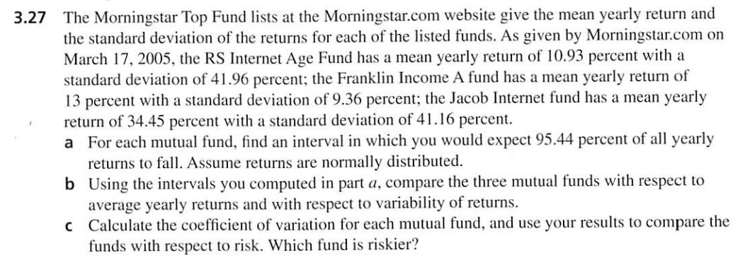
Part (C) needs some explanations.
If we know the mean and standard deviation of a sample then we can calculate coefficient of variation
Coefficient of variation=$\frac{S\text{tan}\text{dardDeviation}}{\text{Mean}}×\text{100}$
The coefficient of variation compares populations or samples having different means and different standard deviations. In the context of situations like the stock fund comparison, the coefficients of variation is often used as a measure of risk because it measures the variation of the returns relative to the size of the mean return. The higher the Coefficient of Variation is the riskier the stock or fund is.
RS Internet Age Fund: 41.96/10.93*100=383.89
Franklin Income A: 9.36/13*100=72
Jacob Internet Fund: 41.16/34.45*100=119.47
So RS Internet Age Fund is riskier.
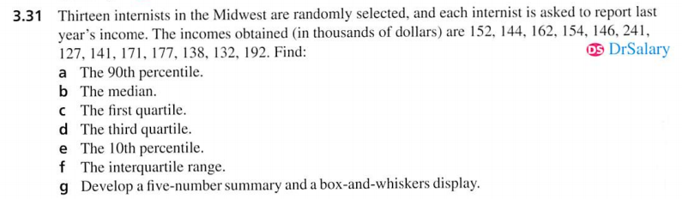
We can use Excel to generate the output of the summary statistics. Click Data Analysis and then choose Descriptive Statistics. Select the right range of the data and generate the results. To produces the confidence interval for the mean, you also need choose the confidence level. For example, in the picture, the confidence level is set to be 95%. 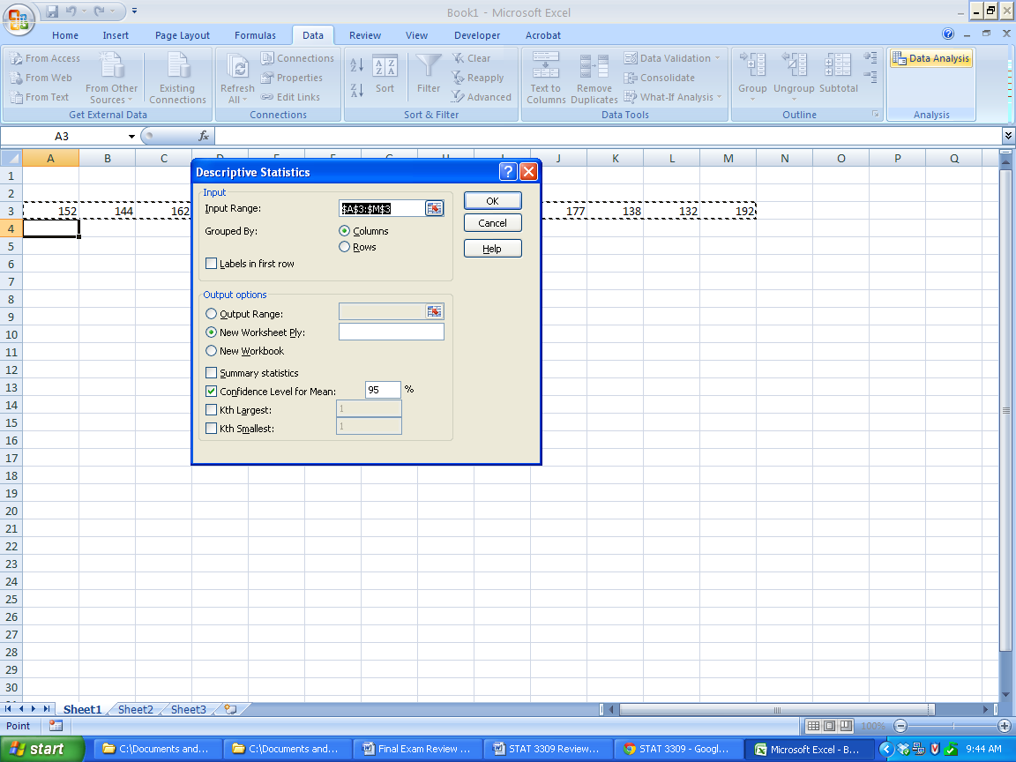
Row1
Mean | 159.7692
Standard Error | 8.498985
Median | 152
Mode | #N/A
Standard Deviation | 30.64353
Sample Variance | 939.0256
Kurtosis | 3.409669
Skewness | 1.695197
Range | 114
Minimum | 127
Maximum | 241
Sum | 2077
Count | 13
Confidence Level(95.0%) | 18.5177

The table is the Excel output. From which you can see the mean of the sample is 159.77, and the standard deviation is 30.64. The margin of error for the 95% confidence interval is 18.52, so the 95% confidence interval is (141.25, 178.29).

